# Force stop an app

* In WeGuard Enterprise, we can forcibly stop an app. On Samsung and LG devices, force stop an app will work.
* To stop the apps forcibly, go to **Devices > Selected Device>Device Details > Applications**. Please refer the below screen

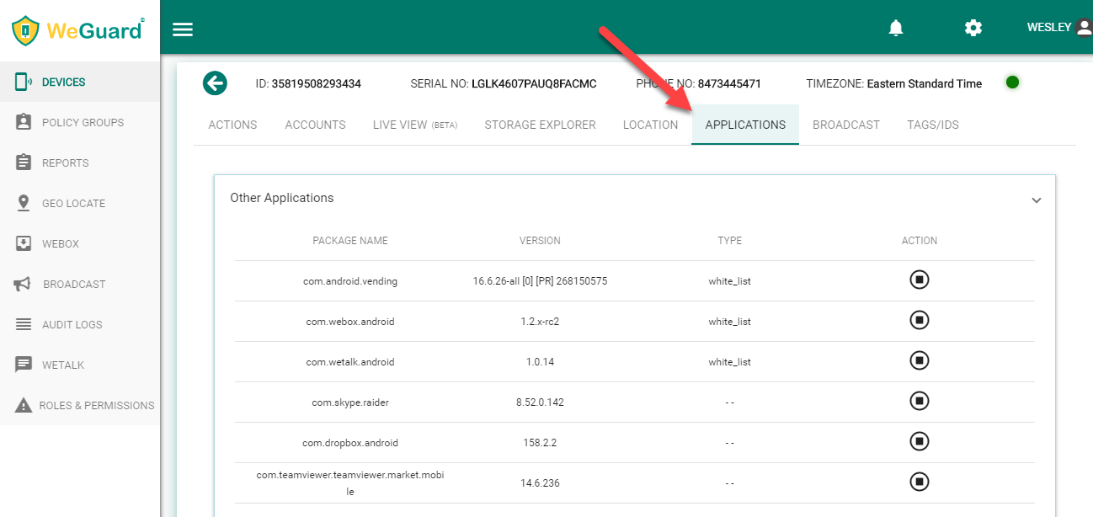

* First, open any app on the device like Drop box, Skype, WeBox, WeTalk, Team Viewer etc.

Please refer the screens

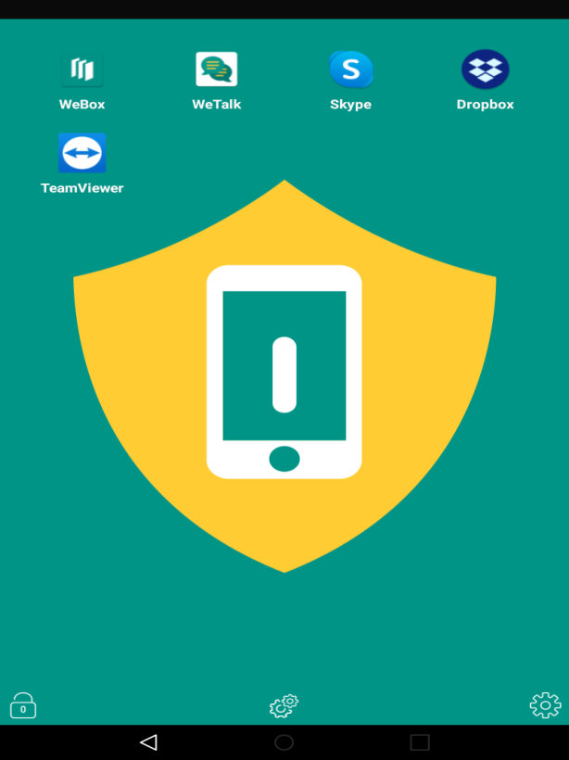

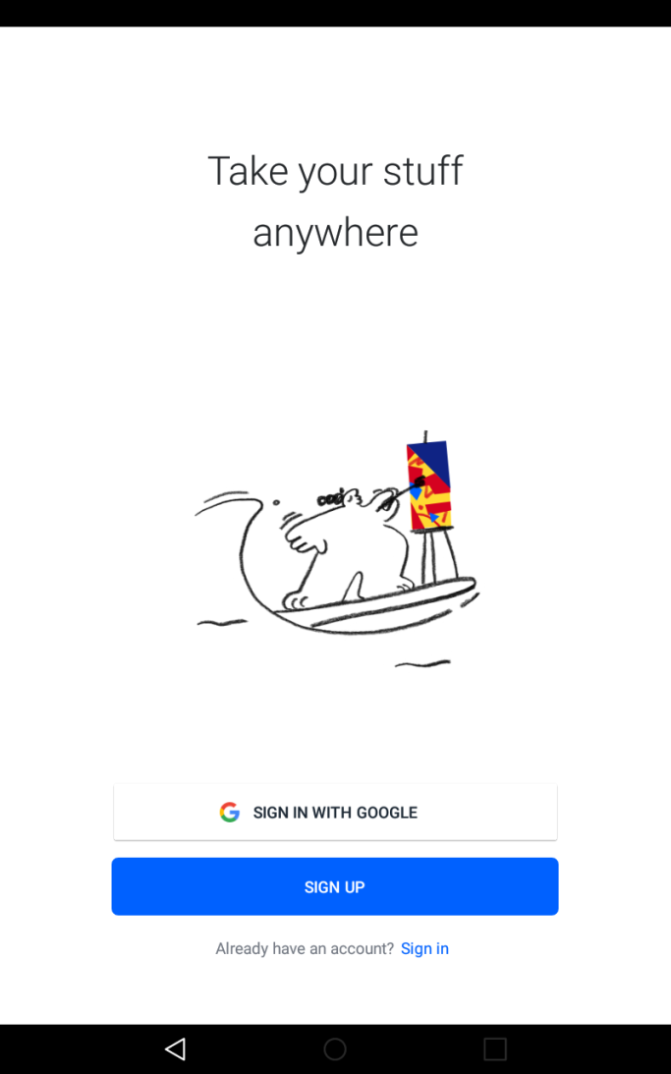

* Go to any app like Skype, Drop box, WeBox, WeTalk and Team Viewer. Click on App stop.pngicon to stop an app.

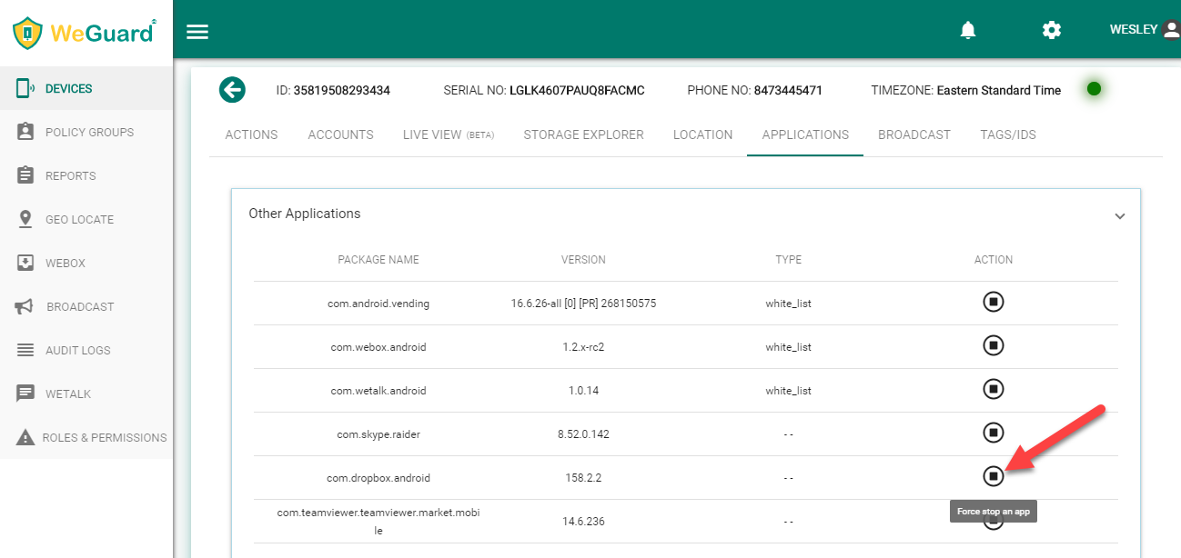

* After clicking on “**stop**” icon. It will prompt a message like “Confirm force stop”.

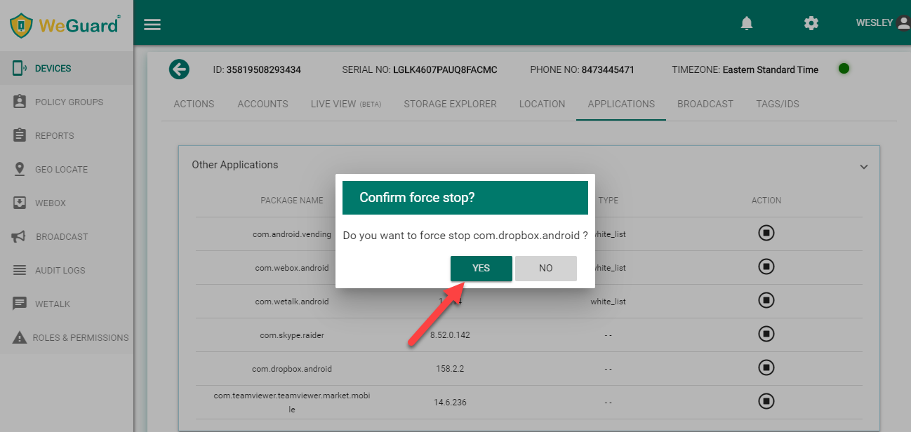

* After clicking on “**Yes**”, the command will be executed successfully.

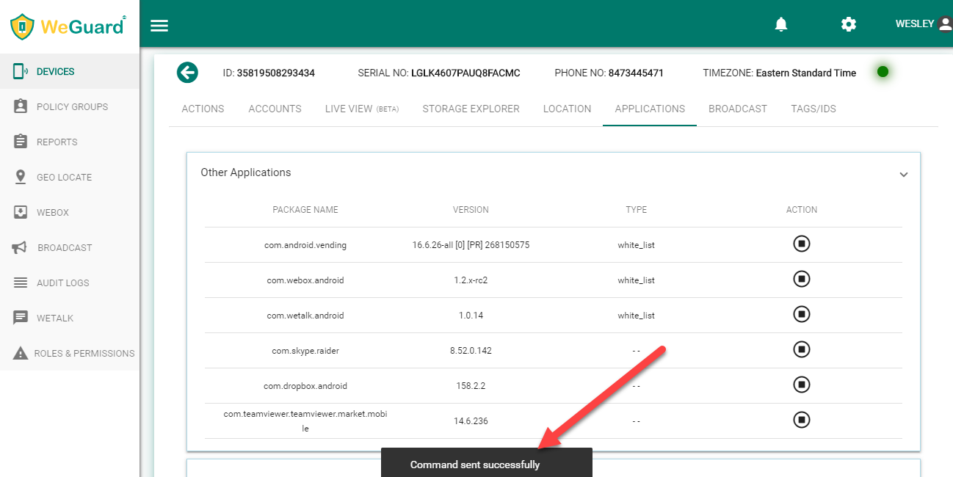

* A message will display at the bottom of the page on the portal.
* After command executing successfully, the app on the device which is already opened that will be closed and it will display the message like “**App is stopped by server policy**”

